LiveScot
Lanark Agricultural Centre
Saturday 26th November 2022

Baking & Crafts Section
£1.00 per entry
PRIZES IN EACH CLASS: 1st Prize £5; 2nd Prize £3; 3rd Prize £2
Sponsored by: Mr and Mrs H Lamont

Quaich for Best In Show (presented by the Scottish National Fat Stock Club)
POINTS: 1st 6 points; 2nd 5 points; 3rd 4 points; 4th 3 points; 5th 2 points; 6th 1 point

 | OPEN SECTION
Class 62 | Flower arrangement depicting a Scottish song
Class 63 | 3 cherry scones
Class 64 | 3 pieces of fudge
Class 65 | 3 squares of almond slice
Class 66 | A jar of strawberry jam
Class 67 | A small jar of homemade tomato ketchup
Class 68 | A sultana cake
Class 69 | Chocolate Swiss roll (filled)
Class 70 | Individual trifle
Class 71 | Filled ½ potato skin
Class 72 | Placemat (any craft)
Class 73 | Sewn peg bag
Class 74 | Mens class – anything edible

 | YOUNG FARMERS
Class 75 | Seniors: A Victoria sponge sandwich filled
Class 76 | Juniors: 3 ginger nut biscuits

* free entry | KIDS SECTION (up to and including 5 years old)
Class 77 | A Christmas hand/ foot print picture
Class 78 | 3 homemade chocolate treats

* free entry | KIDS SECTION (6-10 years)
Class 79 | Christmas ornament painted stones of pebbles
Class 80 | 3 pieces of uncooked traybake

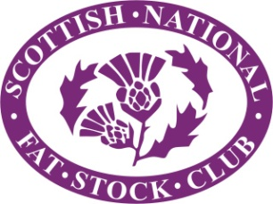
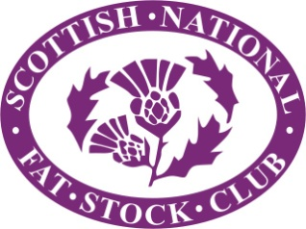
LiveScot
Lanark Agricultural Centre
Saturday 26th November 2022

£1 per entry (minimum entry fee: £5)
Exhibitors need not be members of the Scottish National Fat Stock Club

CLASS  NUMBER | CLASS  DESCRIPTION | NUMBER OF  ENTRIES

NAME: ____________________________________________________________

ADDRESS: ____________________________________________________________

____________________________________________________________

POST CODE: ___________________________ TELEPHONE: ____________________

EMAIL: ____________________________________________________________

Entries close on the day!

Entries to:
Julie Wight, Pumplburn Farm, Wamphray, Moffat, DG10 9NA
Tel: 07769 283004
Cheques should be made payable to: SNFSC

